**FOREST CONSERVATION EVALUATION TOOL (FCET)**

**INSTRUCTIONS**

This document describes the functions of the FCET. For a brief overview of underlying methods and data please see “FCET Metadata.pdf,” which can be downloaded from the FCET dashboard. For new users, it will be helpful to read that document before reading this one.

|  |
| --- |
| ***Citing the FCET:*** Blackman, A. and A. Egorenkov. 2016. Forest Conservation Evaluation Tool. Washington, DC: Resources for the Future. Available at: <http://fc-evaluation-tool.net> |

**TABLE OF CONTENTS**

A. DASHBOARD

*Page*

A.1. HOW TO 3

A.1.1. Description

A.1.2. Instructions

A.1.3. FAQ

A.1.4. Video tutorial

A.1.5. User questions

A.1.6. Email

A.2. ABOUT 4

A.2.1. Metadata

A.2.2. Sponsors

A.2.3. Team

A.2.4. Email

A.3. FEEDBACK 5

A.3.1. User questions

A.3.2. User comments

A.3.3. Email

B. MAP INTERFACE

B.1. ZOOMING 6

B.2. PANNING 6

C. TOOLBOX

STEP 1. DEFINE STUDY AREA 7

STEP 2. DEFINE OUTCOME PERIOD 10

STEP 3. LIMIT POINT TYPES 10

STEP 4. SELECT TREATMENT POINTS 11

Option 1: Upload a Shapefile

Option 2: Manual Selection

Option 3: Select PA Tool

STEP 5. SELECT CONTROL POINTS 16

Option 1. Entire Study Area

Option 2: Upload a Shapefile

Option 3: Manual Selection

Option 4: Proximity to Policy Area

STEP 6. SELECT MATCHED CONTROL POINTS 19

Step 6.1. Select Covariates

Step 6.2. Run Statistical Matching

STEP 7. CHECK BALANCE STATISTICS 21

Step 7.1. Plot Balance Statistics

Step 7.2. Tabulate Balance Statistics

Step 7.3. Tabulate Summary Balance Statistics

STEP 8. RESULTS 23

STEP 9. CHECK SENSITIVITY 24

STEP 10. REPORT 25

**FOREST CONSERVATION EVALUATION TOOL (FCET)**

The Forest Conservation Evaluation Tool (FCET) has three basic components, a Dashboard, a Tool Box, and a Map Interface.



**A. DASHBOARD**

The Dashboard contains four pull-down menus that provide links to background documents and contact information. Note that the redundancy (e.g., contact information is included in several links) is intentional.

**A.1. HOW TO**

The “How to” pull down menu features the following links

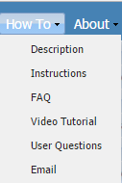

**A.1.1. Description**

Contains a document that provides a brief overview of the FCET

**A.1.2. Instructions**

Contains the document you are reading.

**A.1.3. FAQ** (under construction, to be added)

Contains a document with answers to frequently asked questions

**A.1.4. Video tutorial** (under construction, to be added)

Contains a video tutorial on using the FCET

**A.1.5. User questions**

Contains a digital guestbook in which users can post questions about the FCET. The FCET team at RFF will check the guestbook periodically.

**A.1.6. Email**

Contains email address that can be used to contact the FCET team: [fc-evaluation-tool@rff.org](mailto:fc-evaluation-tool@rff.org%20%20%20)

**A.2. ABOUT**

The “About” pull down menu features the following links

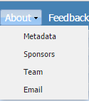

**A.2.1. Metadata**

Contains a document that provides details on the FCET’s methods and data.

**A.2.2. Sponsors**

Contains information on the organizations that have provided funding for the development and maintenance of the FCET.

**A.2.3. Team**

Contains a document with information on the team that built and is maintaining the FCET

**A.2.4. Email**

Contains email address that can be used to contact the FCET team: [fc-evaluation-tool@rff.org](mailto:fc-evaluation-tool@rff.org)

**A.3. FEEDBACK**

The “Feedback” pull down menu features the following links

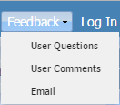

**A.3.1. User questions**  (under construction, to be added)

Contains a digital guestbook in which users can post questions about the FCET. The FCET team at RFF will check the guestbook periodically.

**A.3.2. User comments**  (under construction, to be added)

Contains a digital guestbook in which users can post comments about the FCET. The FCET team at RFF will check the guestbook periodically.

**A.3.3. Email**

Contains email address that can be used to contact the FCET team: [fc-evaluation-tool@rff.org](mailto:fc-evaluation-tool@rff.org)

**B. MAP INTERFACE**

The Map Interface displays FCET data and outputs. We explore these data and outputs below. Here, we briefly cover navigation within the interface.

FCET navigation uses the same tools as Google Map and Open Street Map, and should be familiar to anyone who has used that website.



**B.1. ZOOMING**

Zoom in an out two ways: (i) use the zoom tool pictures above, or (ii) use the scroll button on the mouse.

**B.2. PANNING**

Pan by clicking and dragging the map.

**C. TOOLBOX**

The Tool Box contains the following ten “tools”, each of which can be expanded or collapsed by clicking on the downward or upward pointing arrow on the right-hand-side of the tool.

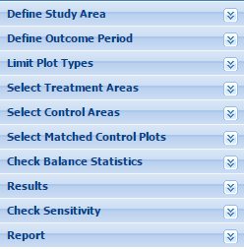

The toolbox was designed to lead users through the ten steps needed to analyze the effectiveness of a forest conservation policy. Each of these ten steps corresponds to a tool (submenu) in the toolbox. In order for the FCET to function correctly, it is important that you click though the Tools in order—starting at the top and moving to the bottom—and close each tool before opening the next.

**STEP 1. DEFINE STUDY AREA**

This tool allows the user to defines a *study area*—an area comprised of first-level administrative units (e.g., states in Mexico, departments in Guatemala) where the effect of the forest conservation policy will be evaluated.

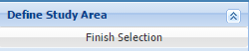

Once this tool is opened, the boundaries of first and second-level administrative units appear in blue on the map interface.

Although it will eventually be expanded, at the FCET’s current geographic scope is Mesoamerica.

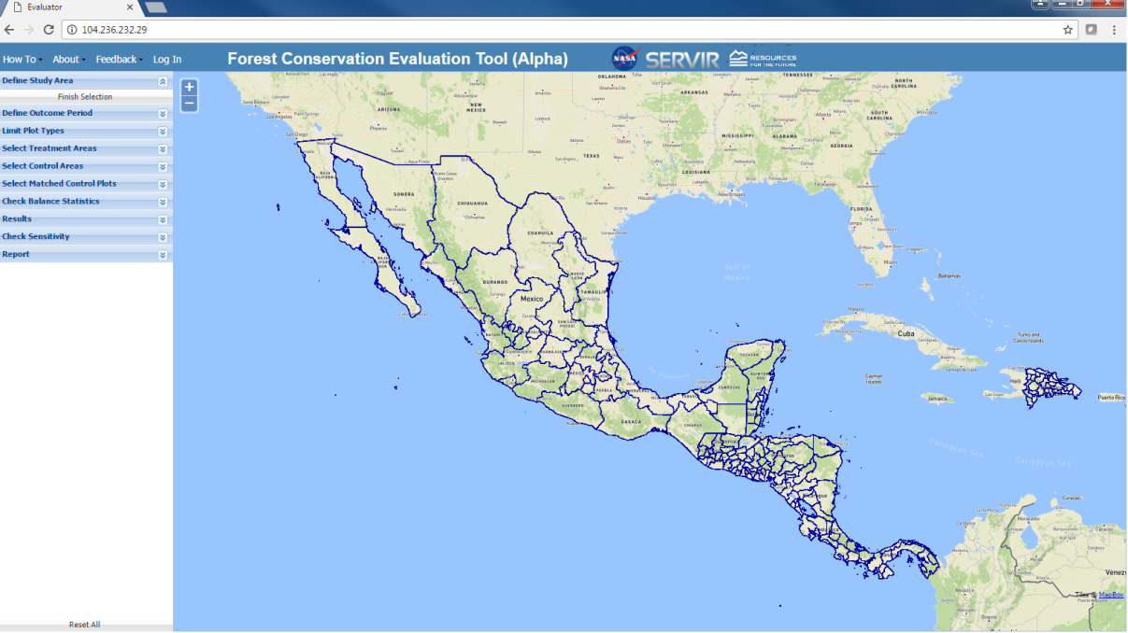

To determine which countries administrative units belongs to, the user can zoom in to the administrative unit in question. Country borders appear in the basemap in bold black lines. El Salvador is pictured below. Note that the black and blue borders do not always line up perfectly. That is due to discrepancies between the underlying basemap and shape files for first-level administrative units.

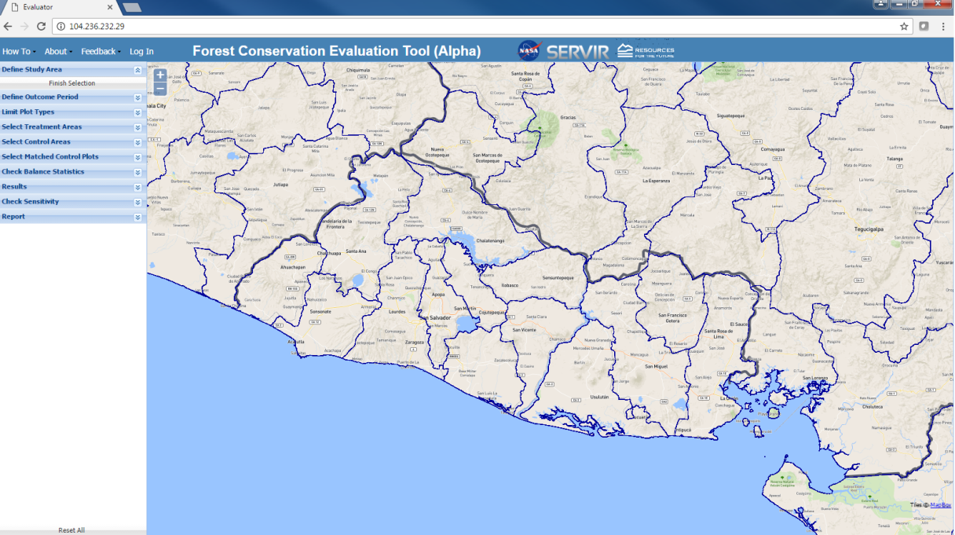

Add administrative units to your study area by ***single***-clicking on them. De-select units by clicking on the a second time.

When selecting administrative units, be careful to click on them one time only. Double-clicking on an administrative unit will select it and then deselect it.

When selected, administrative units will turn beige and forested sample points inside the unit will be displayed in green. The figure below shows FCET map when all administrative units (provinces) in Western Panama are selected.

As discussed in “FCET.Metadata.pdf,” the spatial unit of analysis the FCET uses to measure the effect of a forest conservation policy is a dimensionless point. The FCET relies on a sample of more than one million points in Mesoamerica and the DR. These points were chosen by overlaying a 1km rectangular grid on Mesoamerica and then selecting all points at the intersection of the gridlines that were forested in 2000.

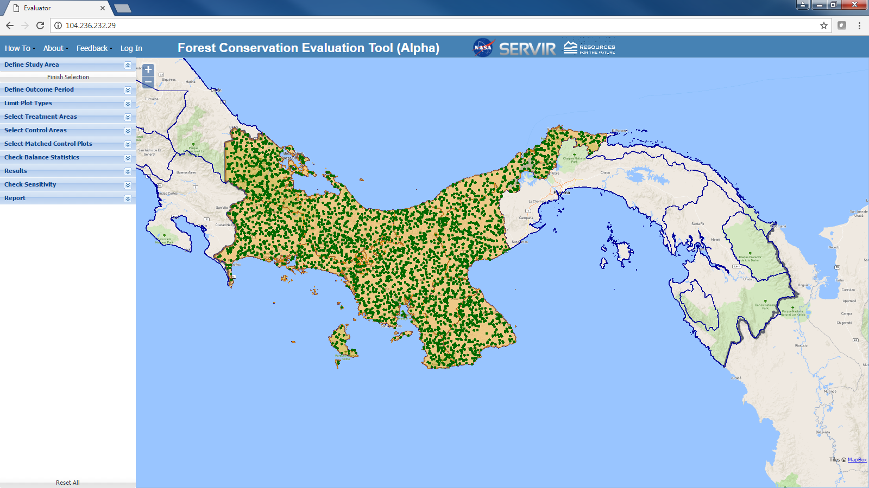

To minimize the computational load associated with displaying points, the FCET does not display all forested sample points (i.e., forested points corresponding to the 1km rectangular grid) in selected administrative units. Rather it displays a random sample of these points. The number of points per unit of land displayed increases as the user zooms in. When sufficiently zoomed in, the FCET displays all forested points on the 1km rectangular sampling grid, that is, all of the points it uses to analyze policy effectiveness.

Once you have selected the administrative units that comprise your study area, click on the “Finish Selection” button in the “Define Study Area” tool. The beige background in the selected administrative units will disappear, and the “Define Study Area” tool will close.

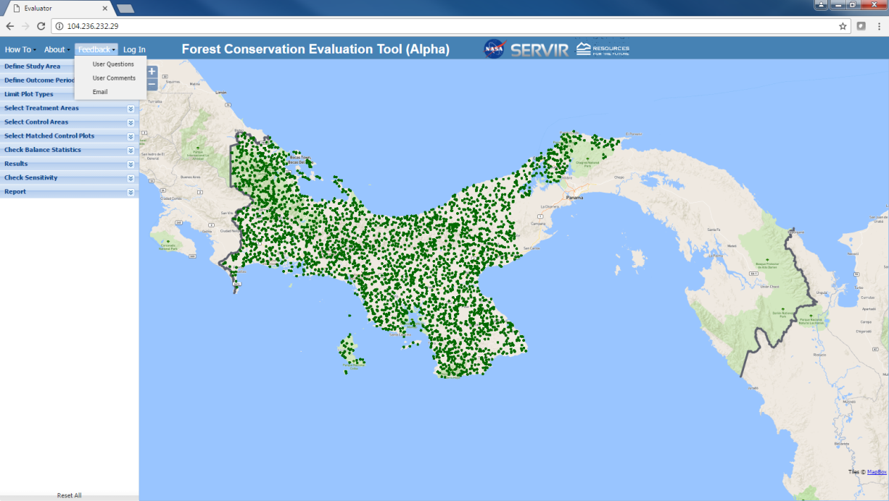

**STEP 2. DEFINE OUTCOME PERIOD**

This tool allows users to select outcome years—the range of years between 2000-2012 over which the effect of the policy on deforestation will be measured. The default is to use the entire 12-year range. However, some users may want to use subsets of that range, e.g., 2000-2005 or 3004-2012. To do that, move the sliders in the tool. The left-hand slider determines the start of the outcome years and the right-hand slider determines the end.

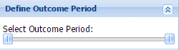

When the slider is moved, the year to which it corresponds to appears above it. The figure below shows the slider positioned to select an outcome period of 2005-2012.

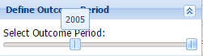

**STEP 3. LIMIT POINT TYPES**

By default, the FCET only includes in the study sample (i.e., the sample of points used to analyze policy effectiveness), those points that had at least 25% forest cover in the year 2000, which is the year of the FCET’s on-board percent forest cover map. This tool allows users to adjust that percent forest cover threshold. For example, as illustrated in the figure below, some users may only want to include in the analysis points with at least 40% forest cover in 2000. Users can adjust the threshold by moving the slider in this “Limit point types” tool, and then clicking on “Submit Selection.”

Note that points are dimensionless and therefore technically speaking cannot have characteristics such as percent forest cover, slope, population density etc. The characteristics that correspond to each point are drawn from data layers used to construct our point-level data. For example, for ‘percent forest cover’ corresponds to the 30mx30m pixel in the underlying 2000 forest cover map generated by Hansen et al. (2013).

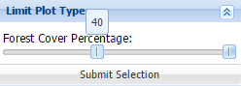

Note that when a higher percent forest cover threshold is selected, the number of points in the study sample is reduced, and therefore the map interface displays fewer green points per unit of land. The figure below illustrates the display when the forest cover threshold is set at 40% (versus the default of 25% in the previous figure).

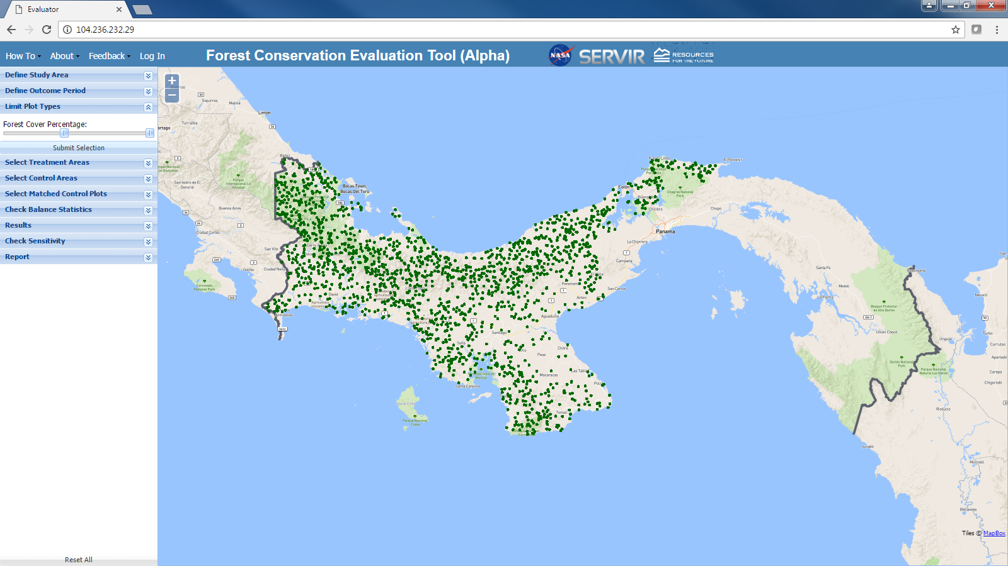

**STEP 4. SELECT TREATMENT POINTS**

This tool allows users to select *treatment points*: those forested points in the study area that have been affected by the forest conservation policy. This can be accomplished in three ways, each of which is described below: (i) uploading a shapefile, (ii) using the manual section tool, and (iii) using on-board data on the location of protected areas (PAs).

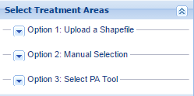

**Option 1: Upload a Shapefile**

This subtool allows users to upload a shapefile that identifies treatment points, for example the boundaries of payments for environmental services (PES) contract areas. Clicking on “Option 1: Upload a Shapefile,” in the “Select Treatment Areas” tool launches opens the subtool.

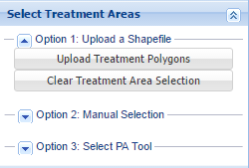

The next step is to click on the “Upload Treatment Polygons” button, which launches the pop-up box pictured below.

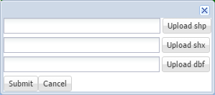

Users must upload three files: a shp, shx, and dbf file. Clicking on the corresponding button in the pop-up box launches an File Explorer window that allows users to browse to, and then “open”, the appropriate file. When the files have been identified, the user must click on “Submit.”

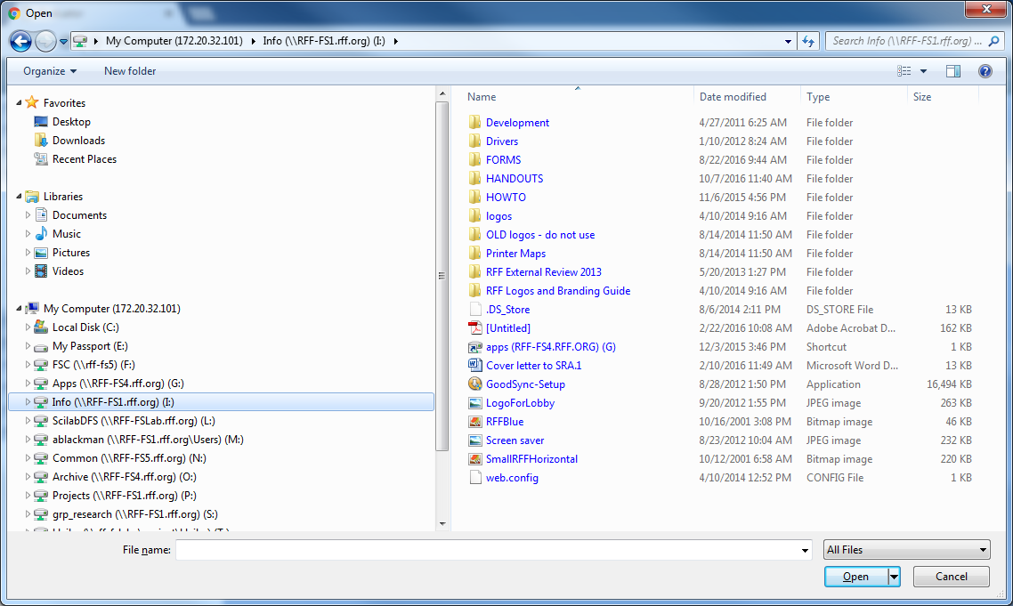

At any time, users can restart the process of uploading treatment polygons by clicking on the “Clear Treatment Area Selection” button in the subtool menu.

**Option 2: Manual Selection**

This subtool allows users to manually delimit the boundaries of polygons that identify treatment points. Three steps are involved.

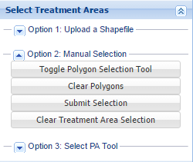

The first substep is to click on the “Toggle Polygon Selection Tool” button. That changes the arrow cursor into an arrow attached to a circle . To delimit a polygon or set of polygons that identify treatment points, position the circle at each vertex of the polygon and single-click, and then double click on the final vertex. That will color the interior of the polygon beige. Repeat that process to create additional polygons.

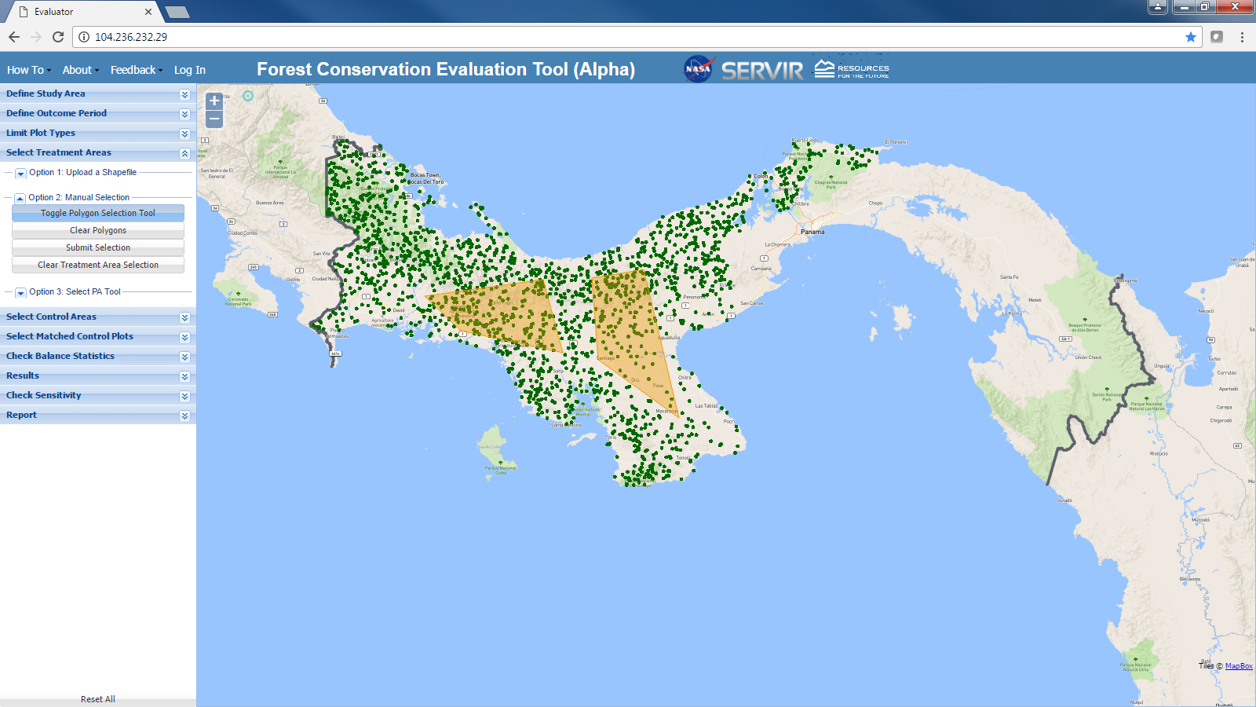

If the user makes a mistaking in positioning vertices and delimiting treatment polygons, they can clear the mistake and restart the process by clicking on the “Clear Polygons” button in the subtool menu.

After the polygons have been delimited, click the “Submit Selection” button to enter them into FCET. The treatment points will be displayed in red and the beige coloring of the polygons will persist. To make the beige polygons disappear, click on “Clear Polygons.” The red-colored points will persist.

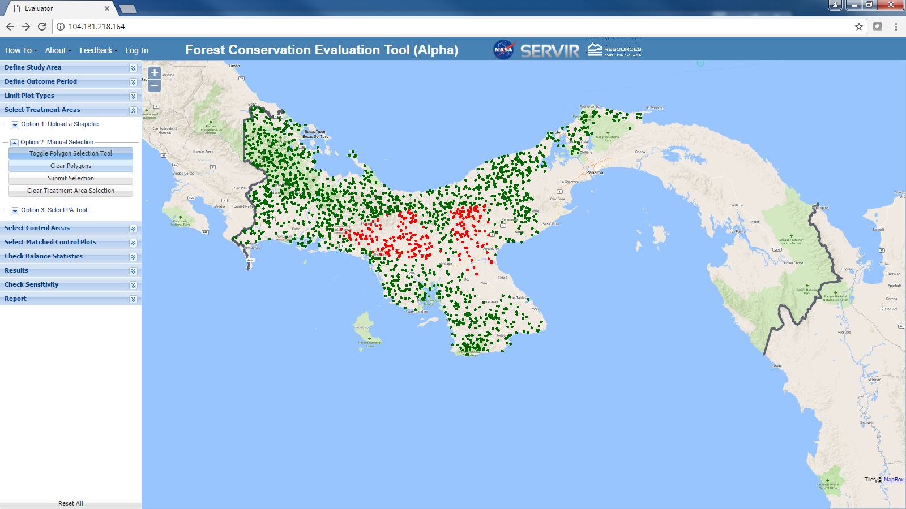

At any time, users can restart the manual treatment point selection process by clicking on the “Clear Treatment Area Selection” button in the subtool menu.

**Option 3: Select PA Tool**

This subtool can used when a protected areas (PAs) are the conservation policy being evaluated. It delimit the boundaries of PAs in the study area using World Data Base of Protected Areas (WDPA) data (for details see “FCET Metadata.pdf,” which can be downloaded from the FCET dashboard).

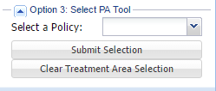

This subtool entails three steps. The first is to click on the down arrow next to “Select a Policy.” A menu will appear with two options: “Protected Areas in Central America” and “Protected Areas in Mexico.”

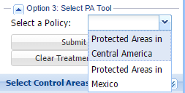

Second, click on the appropriate choice given the location of the study area, and that choice will appear next to “Select a Policy.”

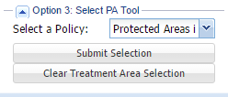

Finally, click on “Submit Selection.” Points inside PAs will be displayed in red.

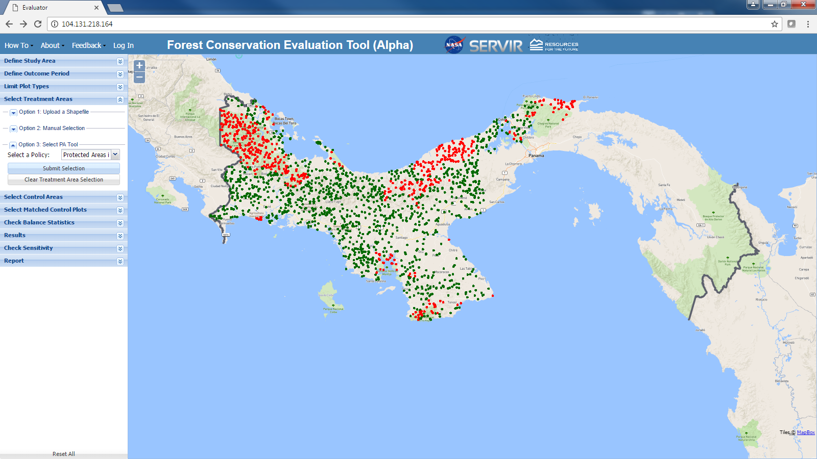

At any time, users can restart the treatment point selection process by clicking on the “Clear Treatment Area Selection” button in the subtool menu.

**STEP 5. SELECT CONTROL POINTS**

This tool allows users to select *control points*: points in the study area not affected by the forest conservation policy that likely to include at least some points ‘similar’ to those affected by the policy. Control points are those from among which matched control points are selected in Step 6 discussed below. Users may want to only use certain points as control points if they believe that they have unobserved characteristics, that is characteristics not captured by the observable characteristics (covariates) included in Step 6. Users can select control points in four ways, each of which is described below: (i) selecting the entire study area, (ii) uploading a shapefile, (iii) using the manual section subtool, and (iv) using the proximity to policy areas subtool.

**Option 1. Entire Study Area**

This subtool selects all or most of the points in the entire study area except the treatment points.

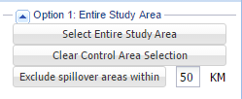

Clicking on the “Select Entire Study Area” button does just that. Control points are displayed in blue.

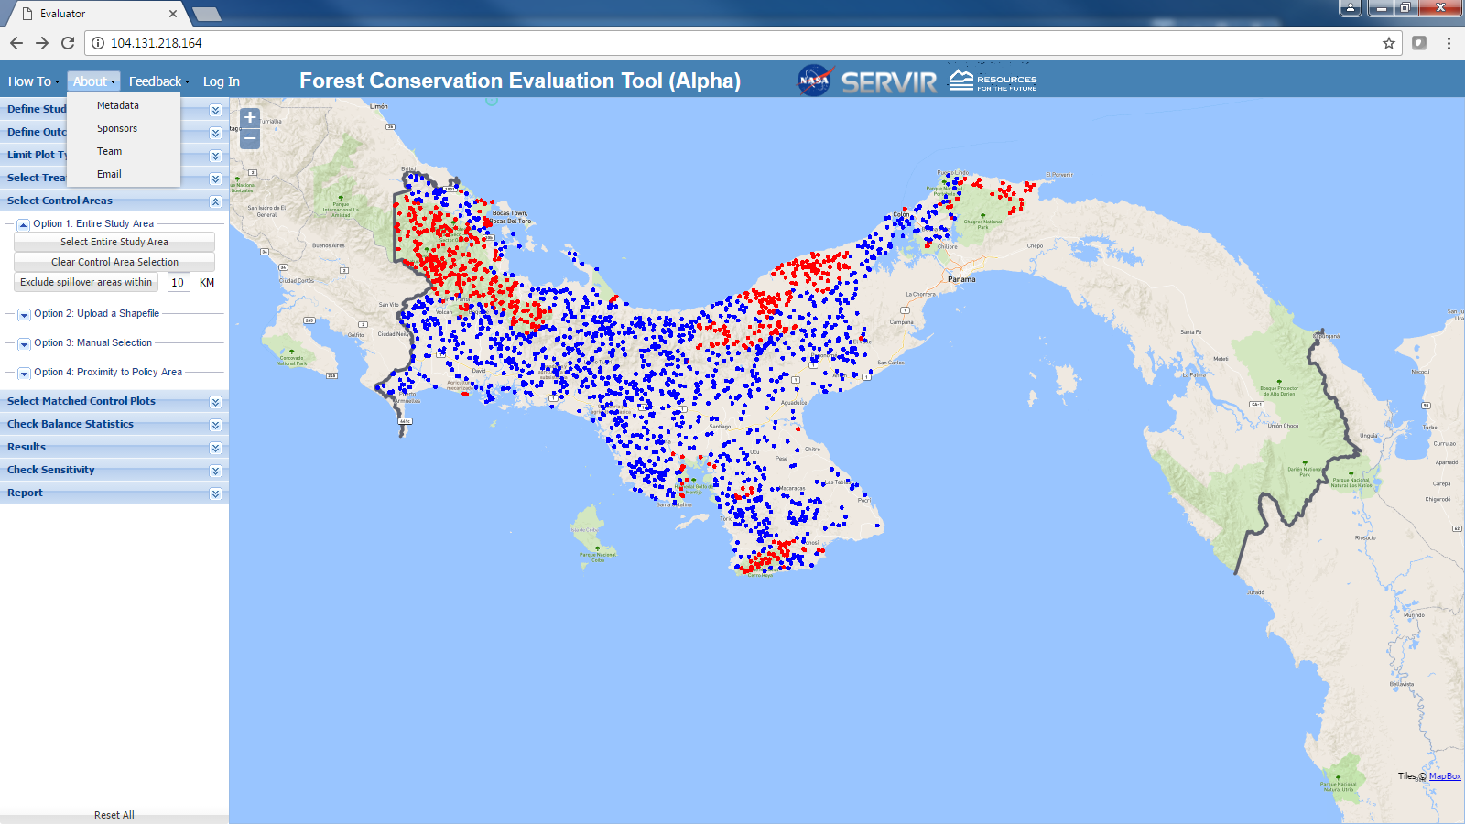

This subtool for selecting control points, along with the other three subtools allows users to exclude from the set of control points all points within a certain distance from treatment points.

The purpose of this means of selecting control points is to control for potential spillover, that is, the effect of the policy on deforestation in areas outside of those in which the policy is implemented. For example, in some cases PAs have been shown to increase deforestation just outside of the borders because farmers, loggers, ranchers and other agents shift their activities from inside PAs to nearby areas outside. In other cases, PAs have been shown to reduce deforestation in nearby areas because they enhance monitoring and enforcement of land use change restrictions.

To implement this option, enter in the box next to “Exclude spillover areas within” the appropriate distance, and then click on the “Exclude spillover areas within” button.

At any time, users can restart the control point selection process by clicking on the “Clear Control Area Selection” button in the subtool menu.

**Option 2: Upload a Shapefile**

For the most part, this subtool works in the same way as the “Upload a Shapefile” subtool used to select treatment areas. Please see the explanation of that subtool above. In the case of selecting control (versus treatment) points, the only difference in functionality is that allows the user to exclude points in spillover areas in the same way as in Option 1.

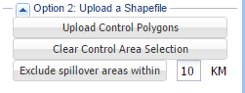

**Option 3: Manual Selection**

For the most part, this subtool works in the same way as the “Manual Selection” subtool used to select treatment areas. Please see the explanation of that subtool above. In the case of selecting control (versus treatment) points, the only difference in functionality is that the user can exclude points in spillover areas in the same way as in Option 1.

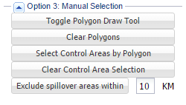

**Option 4: Proximity to Policy Area**

This subtool selects as control points all points within a user-defined distance around treatment areas. Users define the distance using sliders. The left-hand slider sets the minimum distance and the right hand slider the maximum distance. In this way, it is possible to select treatment points within ‘doughnut’ polygons.

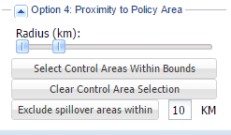

The logic for using proximity to policy areas to select control points is that only points within a certain distance to treatment areas have the same unobservable characteristics as treatment points, that is, characteristics not captured by the covariates associated with Step 6.

**STEP 6. SELECT MATCHED CONTROL POINTS**

This tool allows users to select matched control points, that is control points that are similar to treatment points. The FCET estimates the effect of forest conservation policies on deforestation by comparing the deforestation rates on treatment points with that on matched control points. As discussed in “FCET Metadata.pdf,” which can be downloaded from the FCET dashboard, uses propensity score matching (PSM) to select matched control points. To select matched control points the user must complete three steps.

**Step 6.1. Select Covariates**

The first step is to select from a pre-determined list of 13 land characteristics (covariates), those that will be used to define ‘similarity.” To do that, first click on the “Select Covariates” button.

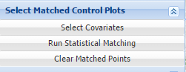

Clicking on this button launches this pop-up box

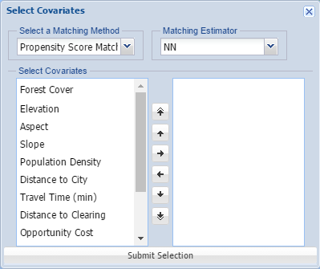

Currently, the matching method and estimator choices are not functional. Users can only use propensity score matching and 1-1 nearest neighbor matching estimator. Additional options are under construction.

Definitions and a detailed description of the 13 covariates in the pop-up box are included “FCET Metadata.pdf,” which can be downloaded from the FCET dashboard.

Select covariates from this list by clicking on them and then clicking on the  button. As in Microsoft applications, you may use shift-click and control-click to select multiple covariates. Clicking on the  button moves selected covariates from the left-hand-side panel in the pop-up box to the right-hand-side panel. In case you change your mind or make a mistake, you can click the  button to move covariates from the right-hand-side panel back to the left-hand-side.

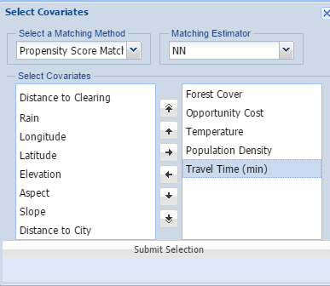

Once you have finalized the list of covariates you want to use, click on “Submit Selection” button. When you do that, the pop-up box will disappear.

**Step 6.2. Run Statistical Matching**

Click on “Run Statistical Matching.” FCET will think for a minute or two, during which time it will display a “wait” symbol. When done, FCET will display matched control points in yellow.

The FCET will no select matched control points until the user clicks on the “Run Statistical Matching” button.

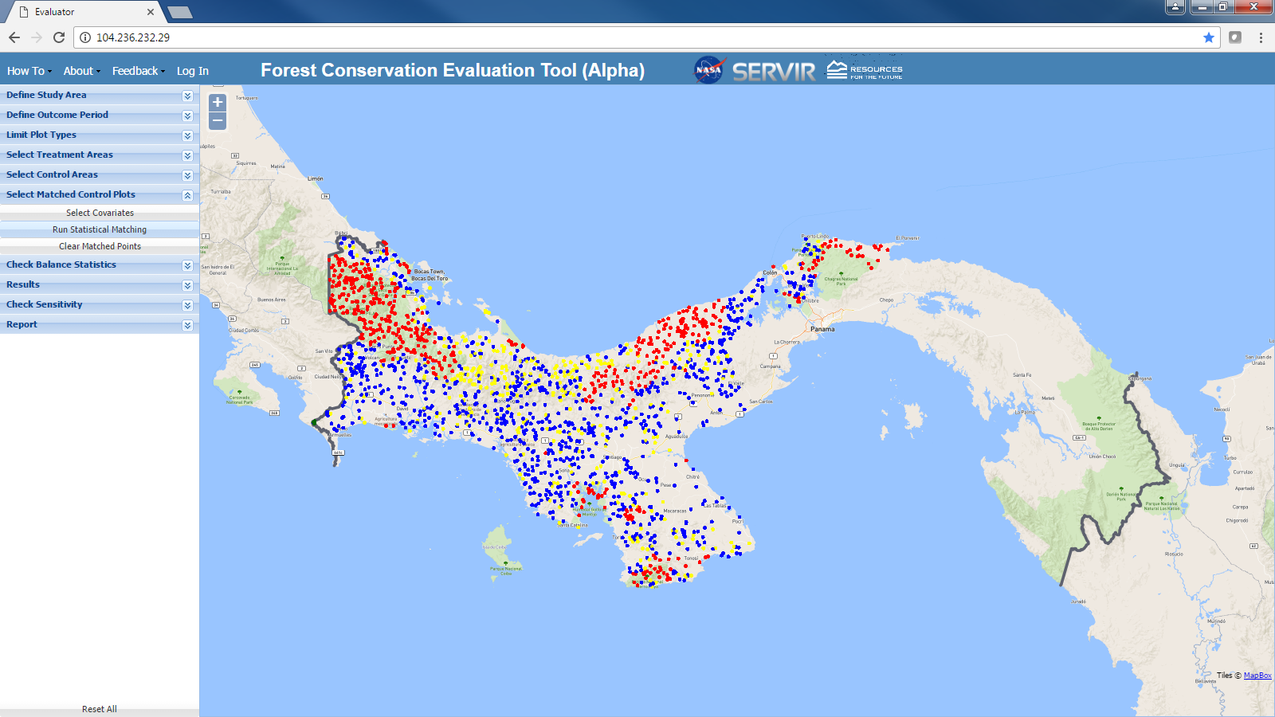

At any time, users can restart the process of selecting matched control points by clicking on the “Clear Matched Points” button in the subtool menu.

**STEP 7. CHECK BALANCE STATISTICS**

This tool allows users to generate *balance statistics*—statistics (in tabular and graphical format) that give the user an idea of how similar the matched control points are to the treatment points. The tool includes three subtools, each of which is discussed below.

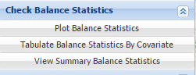

**Step 7.1. Plot Balance Statistics**

Clicking on “Plot Balance Statistics” launches a pop-up box that displays the following graph:

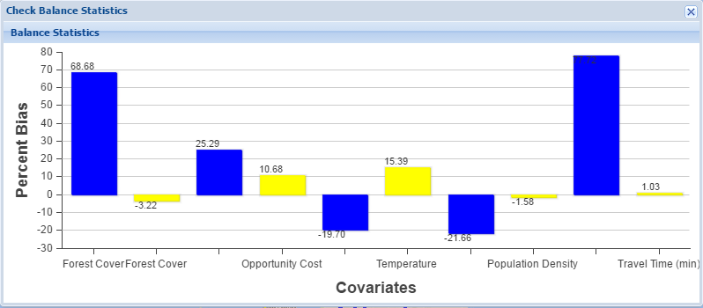

For each of the covariates used to define similarity (i.e., used in the propensity score matching), the figure displays the pre-match bias in blue, and the post-match bias in yellow. The pre-match bias measures the extent to which the mean of the covariate for the sample of treatment points differs from the mean for the sample of control points (all control points, not just the matched control points). Technically, it is the variance normalized difference in those means. The post-match bias measures the extent to which the mean of the covariate for the sample of treatment points differs from the mean for the sample of matched control points. In general, post-match bias will be significantly smaller than the pre-match bias.

**Step 7.2. Tabulate Balance Statistics**

Clicking on “Tabulate Balance Statistics” launches a pop-up box that displays the following table:

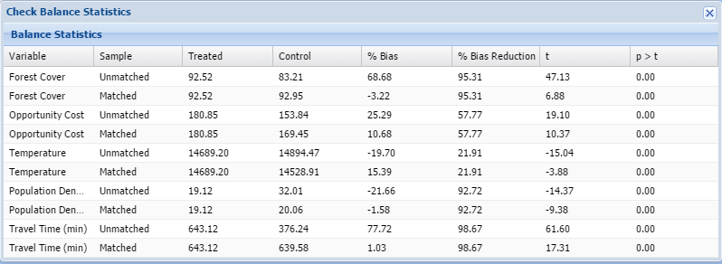

The table includes two rows for each covariate used to define similarity (i.e., used in the propensity score matching). The top row (“unmatched sample”) includes statistics that measure the extent to which the mean of the covariate for the sample of treatment points differs from the mean for the sample of control points (all control points, not just the matched control points). The bottom row (“matched sample”) includes the same statistics but here measuring the extent to which the mean of the covariate for the sample of treatment points differs from the mean for the sample of matched control points. The statistics in each row include: the mean of the treated sample, the mean of the control or matched control sample, the % bias, the % bias reduction after versus before matching, the t-statistic on for statistical test of the null hypothesis that the two sample means are equal, and the probability value for that test.

**Step 7.3. Tabulate Summary Balance Statistics**

Clicking on “Tabulate Summary Balance Statistics” launches a pop-up box that displays the following table:

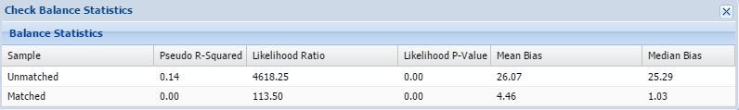

This table includes summary statistics that indicate how similar the sample of treatment points is to the sample of control points (top row) and the sample of matched control points (bottom row). These summary statistics include pseudo R-squared, likelihood ratio, likelihood p-value, mean bias, and median bias. A description of each of these statistics is included in the “FCET Metadata.pdf,” which can be downloaded from the FCET dashboard.

**STEP 8. RESULTS**

This tool allows users to view the results of the analysis of the forest conservation policy’s effect on deforestation in in tabular and graphical format.

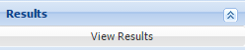

Clicking on the “View Results” button launches a pop-up box that includes results in both graphical and tabular format.

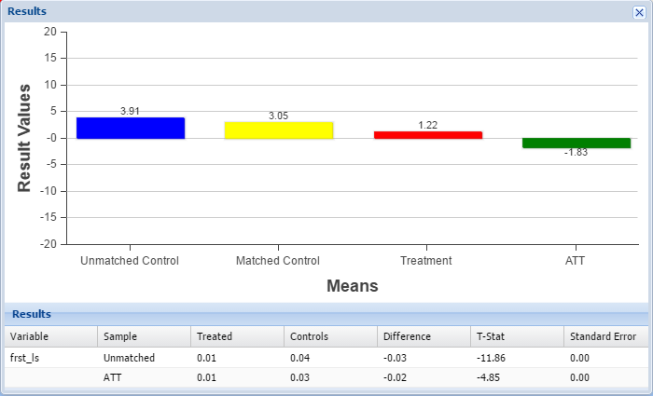

The figure represents the deforestation rates on unmatched control points (blue bar), matched control points (yellow bar), and treated points (red bar). It also represents the difference between the deforestation rate on matched control points and treated points (green bar) which is the forest conservation policy on deforestation (also known as the average treatment effect on the treated ATT), the FCET’s main result.

The table presents similar information in a different format. The top row (unmatched sample) represents the deforestation rate on treated points, unmatched control points, the difference between these rates, a t-statistic on the statistical test that this difference is equal to zero, and the standard error on the difference. The bottom row (ATT) represents the same information for treated points and matched control points.

**STEP 9. CHECK SENSITIVITY**

This tool gives the user a sense of how robust and reliable are FCET results. More specifically, it checks the sensitivity to unobserved heterogeneity of the FCET’s estimate of the effect of the forest conservation policy on deforestation. Further detail on this sensitivity analysis is provided “FCET Metadata.pdf,” which can be downloaded from the FCET dashboard.

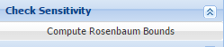

Clicking on “Compute Rosenbaum Bounds” button generates the following table. Again, guidance on how to interpret the table is provided in “FCET Metadata.pdf.”

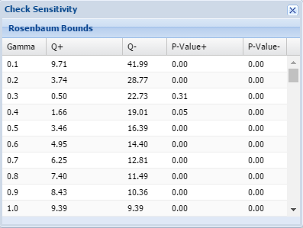

**STEP 10. REPORT**

This tool outputs a report in pdf format, that contains all of the choices the user has made in completing Steps 1-7 above, and all of the results and sensitivity analyses the FCET has generated in Steps 8 and 9. To download the pdf, simply click on the “Download Complete Report” button.

